Chapter 8, Section 2
A System of Transportation
Use the chart to help you take notes. Describe two facts about the way people and goods traveled in the late 1700s and early 1800s.

In 1790, nearly 4 million people lived in the United States, according to the first census, or official count of the population. Most lived within a few hundred miles of the Atlantic coast. By 1820, the population had risen to 10 million. As a result of the westward stream of pioneers, nearly 2 million people were living west of the Appalachian Mountains.

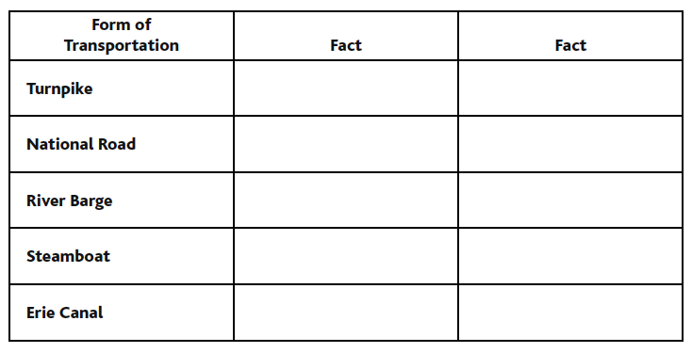
The nation needed good roads for travel and for shipping goods. Private companies built turnpikes, or toll roads. They charged travelers a fee to help pay for construction. Many roads were made of crushed stone. In muddy areas, companies built “corduroy roads” of logs laid side by side like the ridges of corduroy cloth.

In 1803, the new state of Ohio asked the federal government to build a road to connect it to the East. The first section from Maryland to western Virginia opened in 1818. Later, the National Road extended through Ohio and ended in Vandalia, Illinois. Congress did not undertake any other road projects.

Floating downstream on river barges was more comfortable than traveling the bumpy roads. Propelling barges upstream against the current, however, was very slow and difficult. Also, most major rivers flowed north to south, not east to west, where most people and goods were headed.

James Rumsey equipped a small boat on the Potomac River with a steam engine. John Fitch built a steamboat that traveled the Delaware River. Neither boat had enough power to overcome the strong currents and winds of large rivers and open bodies of water.

In 1802, Robert Fulton built the Clermont, a steamboat with a powerful engine. The Clermont traveled the Hudson River from New York City to Albany in 32 hours. By sail, the trip would have taken four days. The Clermont offered passengers sleeping compartments and a smooth, though noisy, ride.

Steamboats greatly improved the transport of goods and people along major rivers. They also spurred the growth of river cities like Cincinnati and St. Louis.

The existing river system did not effectively tie the East to the West. De Witt Clinton came up with a plan to build a canal—an artificial waterway—to connect Albany on the Hudson River to Buffalo on Lake Erie.

Workers on the Erie Canal built locks—separate compartments where water levels could be raised and lowered. Locks raised and lowered boats in places where canal levels changed. The 363-mile canal opened in 1825. At first, steamboats were not allowed. Their powerful engines damaged the canal’s embankments. Instead, teams of mules or horses pulled barges. Later, the embankments were reinforced to allow steam tugboats to pull barges.

The success of the Erie Canal touched off an explosion of canal building. Canals lowered the cost of transporting goods. They helped towns prosper along their routes. Canals also helped unite the growing country.

The first wave of westward migration started before the 1790s. It led to the new states of Vermont, Kentucky, Tennessee, and Ohio. The second wave, beginning between 1816 and 1821, resulted in the states of Indiana, Illinois, Mississippi, Alabama, and Missouri.

Pioneer communities tended to form along great rivers, so they could ship their crops to market. Canals enabled people to settle farther away from rivers. People also tended to settle with others from their home communities.

Western families gathered for social events. Men took part in sports such as wrestling. Women met for quilting parties. Families participated in cornhuskings, in which they shared the task of stripping husks from corn.

Improved transportation enabled Americans to buy goods produced in distant places. The new transportation also led to home delivery of the mail in 1825. People in remote areas could then read about national issues in newspapers delivered directly to them.

