Chapter 8, Section 3

Reading Essentials
Use the diagram above to help you take notes. Compare the concerns of factory workers to the main concern of factory owners in the mid-1800s.

Between 1820 and 1860, more and more of America’s manufacturing shifted to factories. The factory system, established in Lowell, Massachusetts, brought the entire production process under one roof.

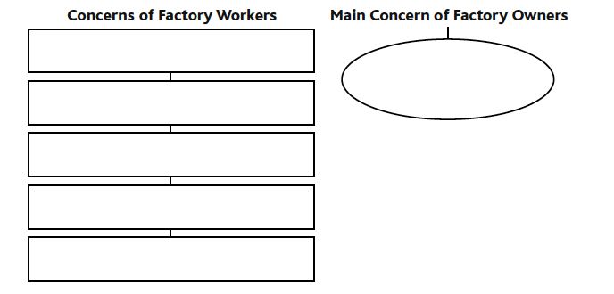
Working conditions in factories worsened. Factory owners required employees to work long hours. By 1840 factory workers averaged 11.4 hours a day. On-the-job injuries were common. The fast-moving parts on machines created dangerous conditions, especially for child workers. In summer, factories were stifling. Heat created by working machines added to the misery. Air conditioning had not been invented yet. Workers suffered in winter as well because few factories had heating.

Profits, not employee comfort and safety, concerned factory owners most. They could easily replace unhappy workers. No laws existed to protect workers. Workers began to organize unions to push for better working conditions. Skilled workers formed trade unions—organizations of workers with the same trade or skill. In the mid-1830s skilled workers in New York City staged strikes, refusing to work in order to put pressure on employers. Workers wanted higher wages and a workday limited to 10 hours.

Slavery had mostly disappeared in the North by 1820. Racial prejudice—an unfair opinion not based on facts— and discrimination—unfair treatment of a group— remained. In most communities, free African Americans were barred from public schools and public facilities. They were forced to use segregated, or separate, schools and hospitals.

Some African Americans succeeded in business. For example, Samuel Cornish and John B. Russwurm founded the first African American newspaper.

Women suffered discrimination as well. Employers paid female factory workers less than male workers. Unions excluded women. Men wanted women to stay out of the workplace to make more jobs available to men. Sarah G. Bagley founded the Lowell Female Labor Reform Organization and petitioned the state for a 10-hour day. The legislature did not discuss the woman’s petition.

The growth of factories spurred the growth of Northern cities. People looking for work moved to cities where most factories were located. The population of New York City, the nation’s largest city, reached 800,000. Towns such as St. Louis, Pittsburgh, and Cincinnati, grew into big cities. Their location on branches of the Mississippi River helped them become centers of trade between Midwestern farmers and cities of the Northeast. Shipping on the Great Lakes turned Buffalo, Detroit, and Chicago into major cities.

Immigration also contributed to the growth of cities. The number of people arriving from other countries greatly increased between 1840 and 1860. The Irish were the largest group. Many left Ireland to escape the Great Irish Famine. A famine is an extreme shortage of food. Potatoes were the main food source in Ireland. When disease destroyed the crop, many people died. Most Irish immigrants were farmers, but they lacked money to buy land in the United States. Instead, many took low-paying factory jobs or manual labor, such as working on the railroads, in the North.

Germans were the second-largest group of immigrants. Some came seeking opportunity. Others left Germany because a democratic revolution failed there. Many Germans arrived with enough money to buy farms or open businesses. They prospered in many parts of the country. Immigrants brought with them their languages, customs, and religions. Previously, most Americans were Protestants from Great Britain or Africans forced into slavery. Most of the Irish and about half the Germans were Catholic.

Some Americans, known as nativists, opposed immigration. They feared immigration threatened the future of “native” or American-born citizens. Some accused immigrants of taking jobs from “real” Americans. They were angry that many immigrants would work for lower pay. Some nativists accused immigrants of bringing crime and disease to American cities.

Nativists formed secret anti-Catholic societies. In the 1850s, they created a new political party: the American Party. To protect the secrecy of their organization, nativists often responded to questions with “I know nothing.” As a result, the American Party came to be known as the Know-Nothing Party. The Know-Nothings wanted to extend the waiting period for citizenship from 5 to 14 years. They also wanted to ban foreign-born citizens from holding office. The Know-Nothing movement split into Northern and Southern branches over slavery.

